**GOVERNMENT COLLEGE OF ENGINEERING [IRTT]**

**ERODE: 638 316**



**Electronics and Communication Engineering**

**NAAN MUDHALVAN**

**DIGITAL MARKETING**

**ASSIGNMENT**

NM ID: B6FCC113FA82F26AD04439C195419051

NAME: JEEVA ANANTH V

BRAND NAME: DOSS DISTILLERIES

CATEGORY: BEVERAGE MANUFACTURER

1.Create a blog or website using Blogspot and WordPress. Customize the theme design and post new article with 500 words.

Link: Blog using Blogspot

<https://dossdistilleries.blogspot.com/>

Screenshots:

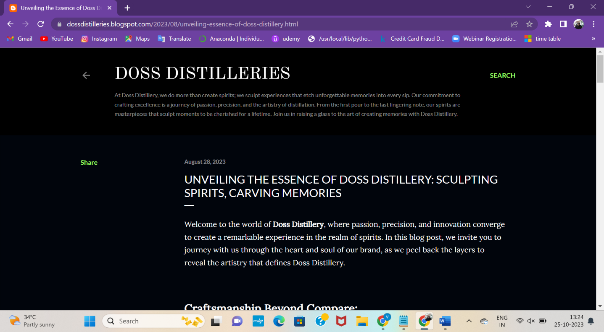

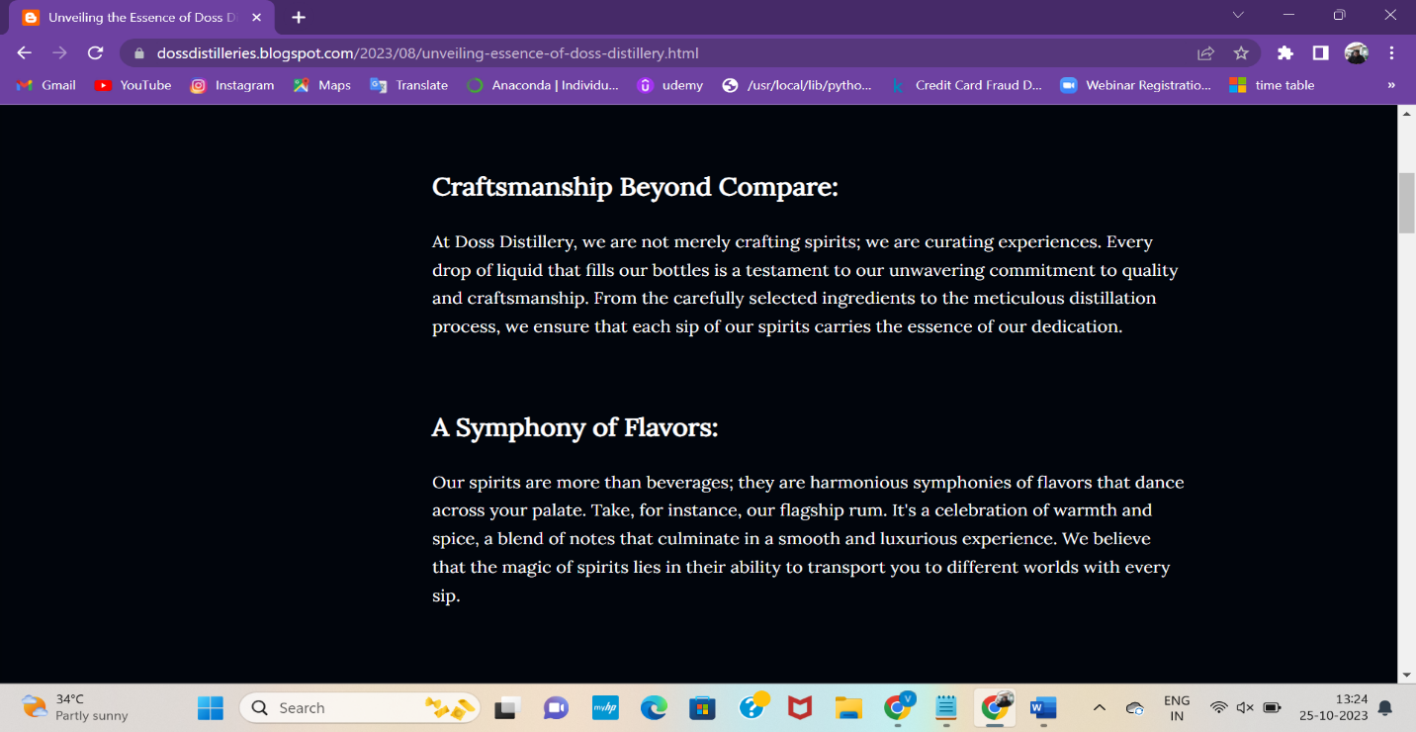

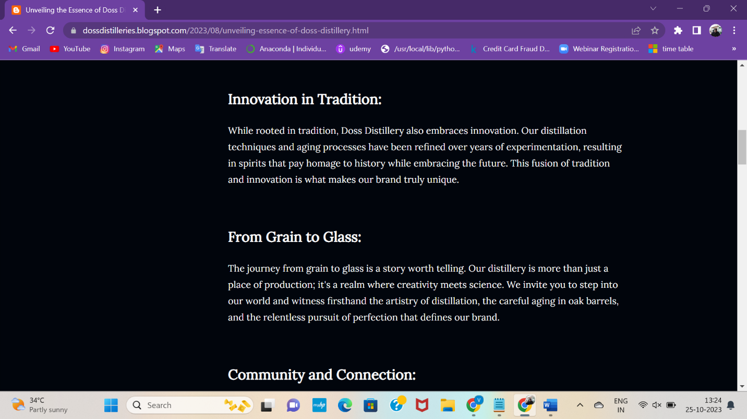

2.Create a New Facebook Business Page and post one social media poster for your brand.

Link: Facebook business page

<https://www.facebook.com/DossDistilleries?mibextid=ZbWKwL>

Screenshots:

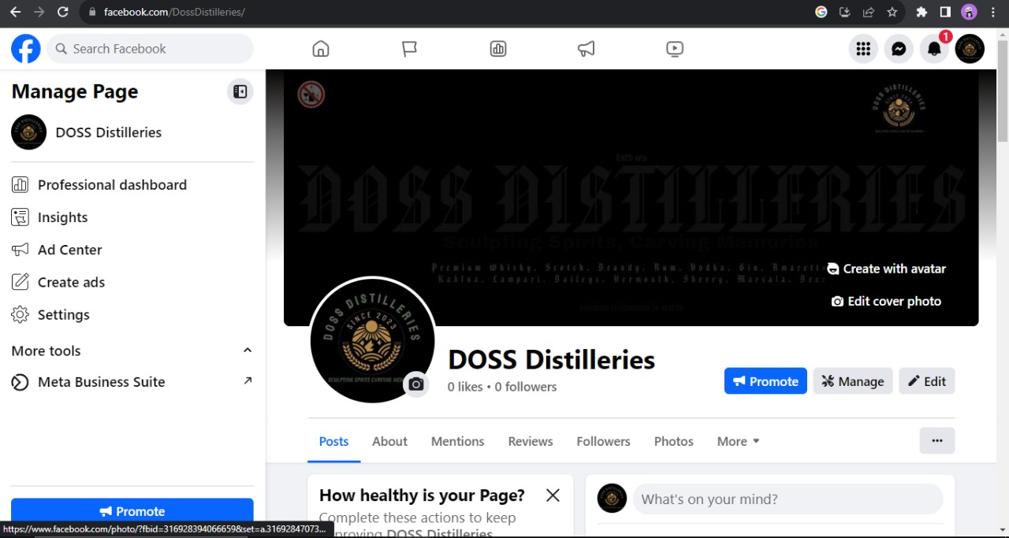

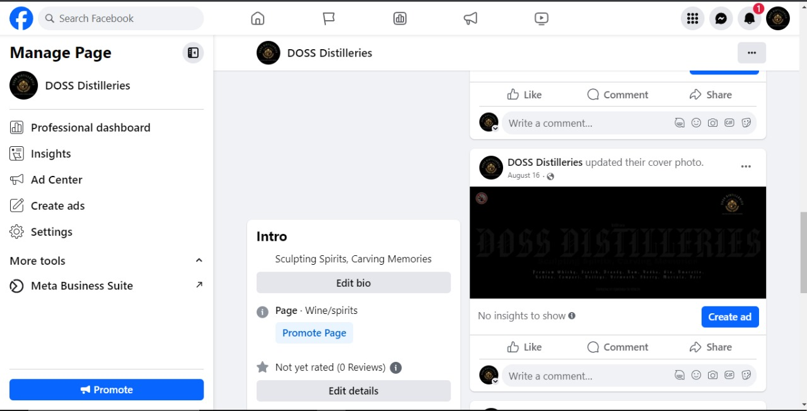

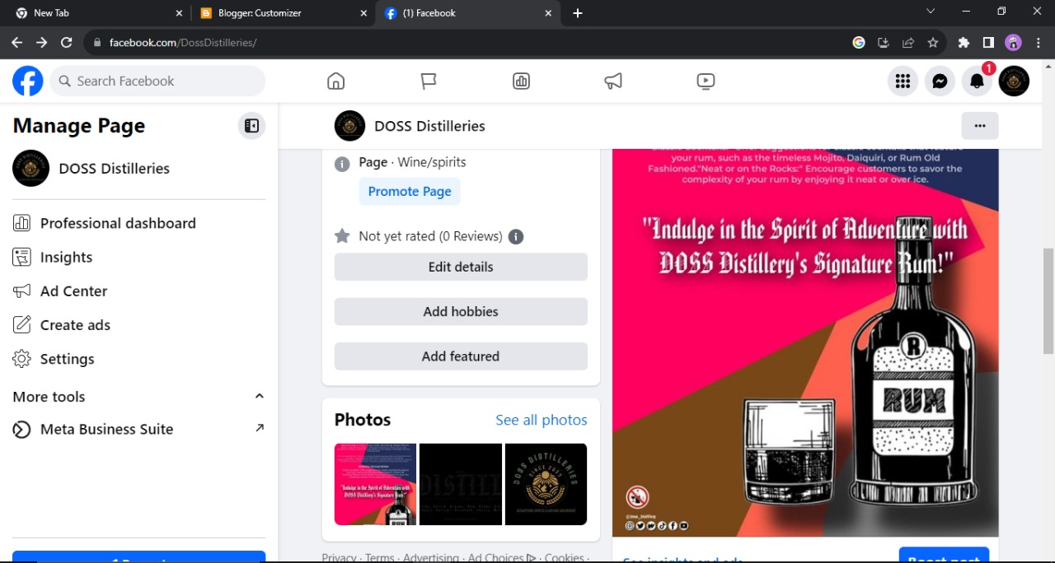

3.Create and design a social media advertisement poster using canva.

Link: Infographics Page Design using canva

<https://dossdistilleries.blogspot.com/2023/08/unveiling-artisans-elixir-whiskey-of.html>

Screenshots:

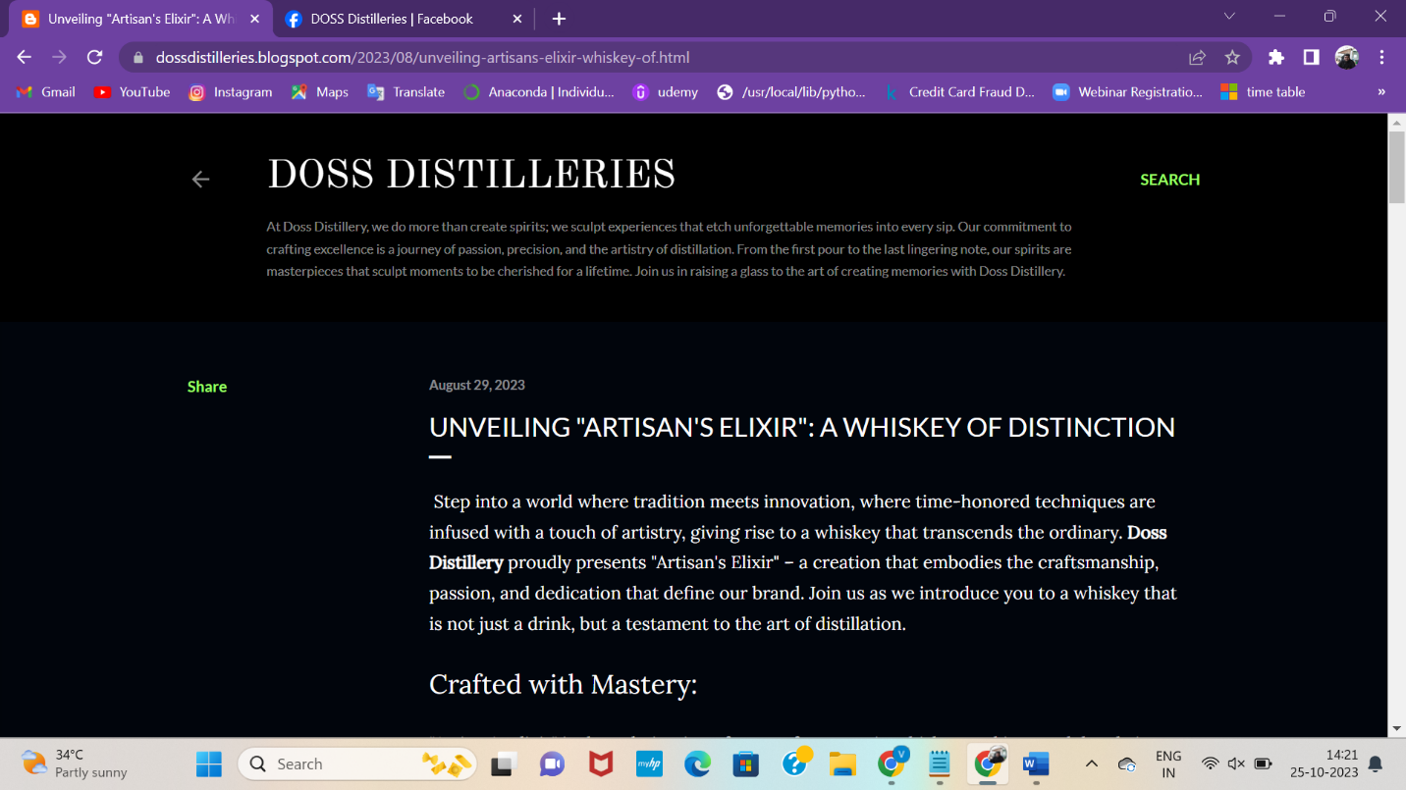

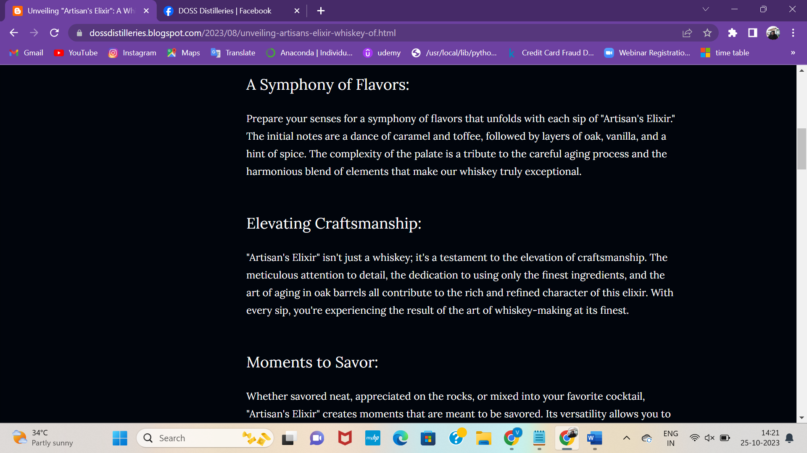

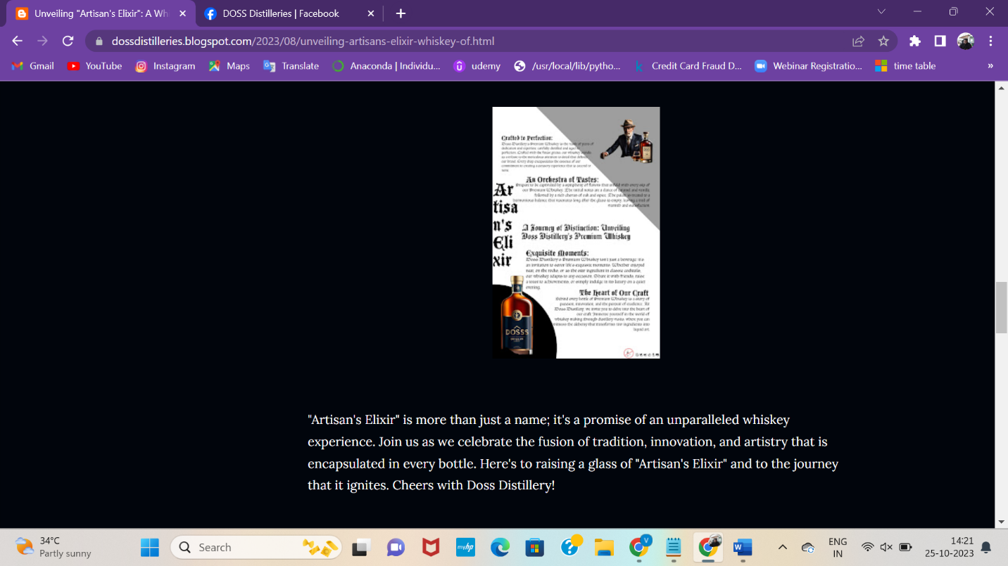

4.Create email newsletter design using MailChimp or canva tool.

Link: Email newsletter design using canva

<https://dossdistilleries.blogspot.com/2023/09/stay-in-know-with-doss-distillerys.html#more>

Screenshots:

